Listening links to use when preparing for the concert at home between our rehearsals:

1. “Dixit Maria” by Hassler
https://www.youtube.com/watch?v=Wd7s40s-Ltw

2. “If ye love me” by Tallis
https://www.youtube.com/watch?v=eqt005j1dB0&list=RDUbUHycl37p4&index=12

3. “Weep O Mine Eyes” - by Bennet
https://www.youtube.com/watch?v=Z5qTpAG1Efo

4. “Gloria in Excelsis” by J S Bach (from “Magnificat” BWV243a)
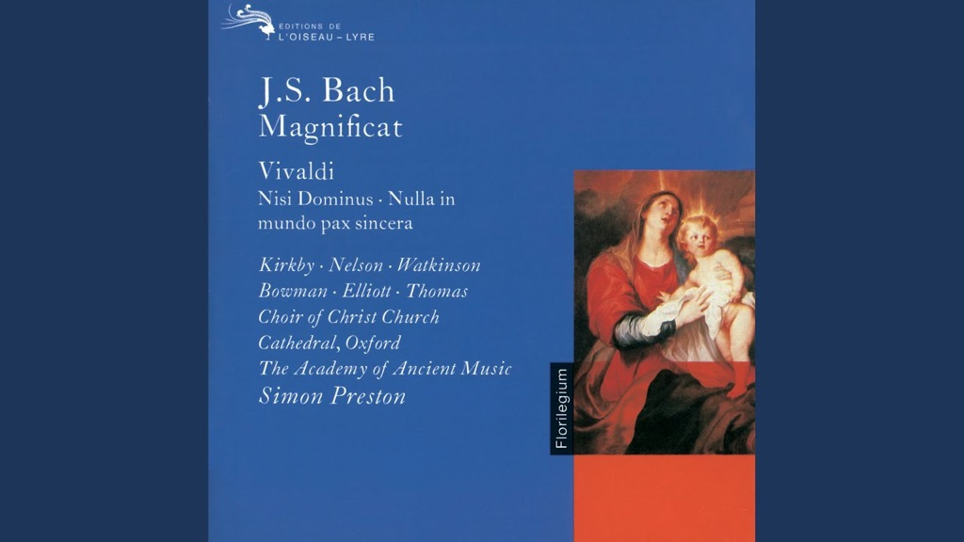
J.S. Bach: Magnificat In E-Flat Major, BWV 243a - 10. Gloria in excelsis Deo
youtube.com

5. “Jesus Bleibet” by J S Bach
https://www.youtube.com/watch?v=U9K7rvhkliU

6. “Thou Knowest Lord” by Henry Purcell
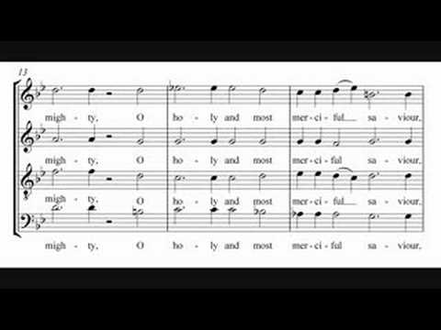
Thou Knowest Lord The Secrets Of Our Hearts
youtube.com

7. “Zadok the Priest” by G F Handel
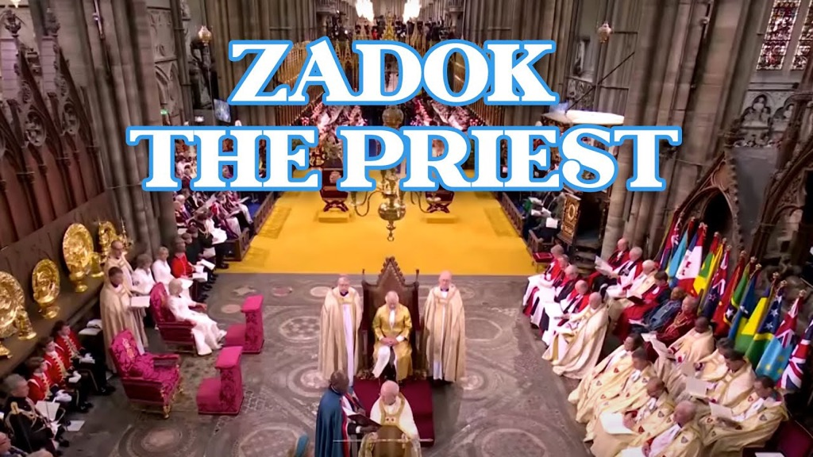
Zadok the Priest - G.F Handel | King Charles III Coronation 2023.
youtube.com

8. “Dies Irae” by Mozart
https://www.youtube.com/watch?v=RKJur8wpfYM

9. “Rex Tremendae” by Mozart
https://www.youtube.com/watch?v=SKityhJZDV0

10. “Lacrimosa” by Mozart
https://www.youtube.com/watch?v=MKYZ1NTfc7Q

INTERVAL

11. “Linden Lea” by Vaughan Williams
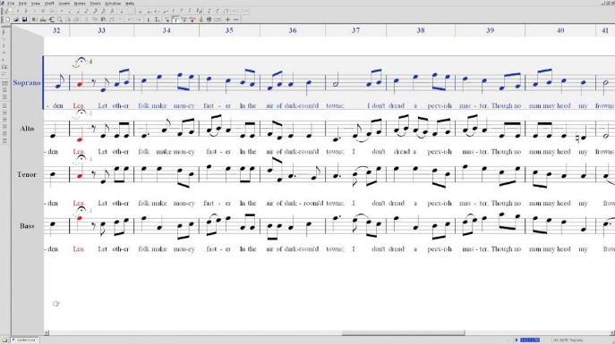
Linden Lea - SATB
youtube.com

If you subscribe to David Lauria, click on his name, then Videos, he has done a video where each part of the choir is dominant, Soprano, Alto, Tenor and Bass.

12. “O Taste & See” by Vaughan Williams
https://www.youtube.com/watch?v=heiiATCrwVQ

13. “Evening Hymn” by Balfour Gardiner
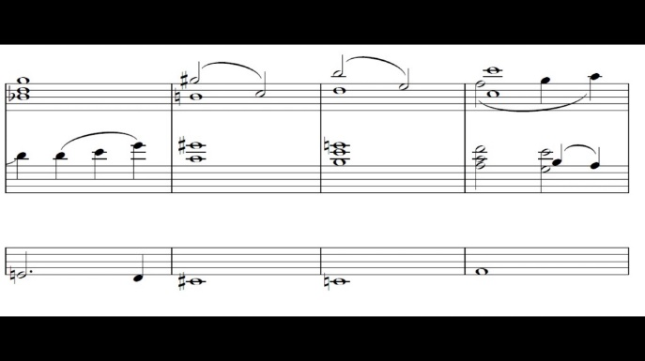
Evening hymn - Balfour Gardiner
youtube.com

14. “The Road Home” by Stephen Paulus
https://www.youtube.com/watch?v=nsE-ZYL_Q1M

15. “Eternal Rest” by James Whitbourn

Luminosity: Eternal Rest by James Whitbourn
youtube.com

16. “Alleluia Jubilate” by James Whitbourn
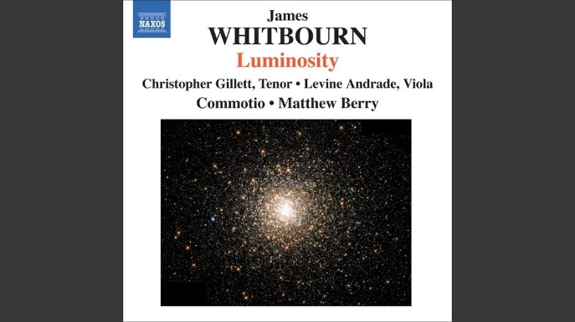
Alleluia jubilate
youtube.com

Encore: “Come to the fair” by Easthope Martin
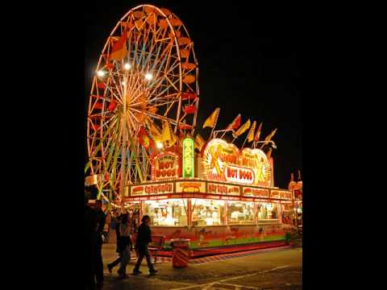
SPCC Songs - Come To The Fair
youtube.com

NB: Having just compiled this list of links and re-visiting and listening to all these pieces of music myself, these two may be dropped if we’re running out of rehearsal time to prepare them for performance:
A) “Gloria in excelsis” J S Bach
B) “Eternal Rest” James Whitbourn

